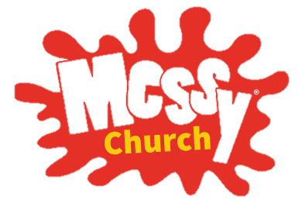
GOD’S PROMISE

Welcome to
MESSY CHURCH at HOME
April 2020
Uniting Church

Hello!
GOD’S PROMISE
How are you going? The school holidays are finished and people are working from home and the world is in a different place to usual. But it is no reason miss out on Messy Church. So the team thought let’s just do it in another way! We have put together a booklet for your family to enjoy.

We hope your family is keeping safe and making the most of this time. Maybe your family usually goes away for the holidays, maybe you go and see grandparents or cousins, so it might have seem a little strange this year to have a holiday at home. But one thing we as church know is that no matter what is happening – how weird things seem, or how challenging our circumstances are – God’s promise is to be with us always.
Messy Church theme today is ‘God’s promise’ and our symbol is the rainbow. We’ve just had Easter where we have remembered again the wonderful gift Jesus gives us in his death and resurrection. Now we can affirm the promises of God’s love and hope for us. The rainbow is an old symbol – in the book of Genesis the rainbow shows Noah that God promises are true, and that it is a sign of God’s everlasting covenant between God and all living being on earth (Gen 9:16).
God bless
Messy Church Team

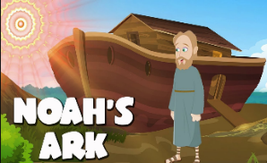
To prepare for Messy Church you could have someone in your family make a worship/church focus (use plants, special items, pictures, make a cross, use messy church logo, anything really). It could be on a coffee table or the dining table, be messy or simple and represent church for you/your family. Gather round the focus and say “welcome to Messy Church, we are glad to be here”.
Read or listen to the story of
You can read the story from the Bible in
Genesis chapter 6-9 or for a shorter version read from a
Children’s Bible or watch a YouTube –here is one from the Beginners Bible https://www.youtube.com/watch?v=onnEaINBaGg

Talk about the story with others: - What did you like about the story? - What was strange about the story? - What did you find out about God in the story? - If you were Noah what would you have done? - As your own question. - If you were one of Noah’s kids what would you say to Noah and God about building the ark? - - - When you see a rainbow what do you think about? Here is a funny song to sing. https://www.youtube.com/watch?v=YFieerX9RU8

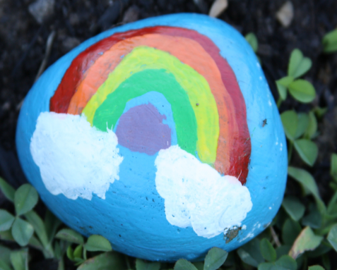
Paint a rock as a symbol of how rock solid God’s promise is!
Pray a rainbow… Then God said ‘I am giving you a sign of my covenant with you and with all living creatures of all generations to come. I have placed by rainbow in the clouds. It is a sign of my covenant with you and with all the earth. Genesis 9:12-13 NLT
Your text here
Your text here

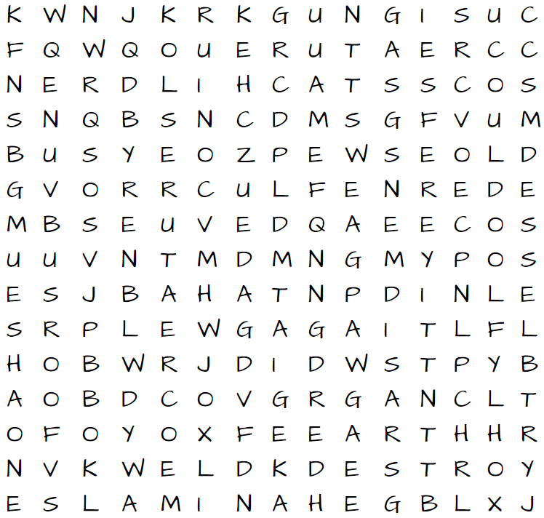
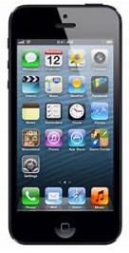
FIND A WORD Noah and the Ark
Rainbow prayer hunt
Go and search around your house and try to find an item of each of the colours below. Gather round your church/worship focus and read a prayer for each colour or pray your own. You may like to pray for your family too.
RED Thank you, God, that you love us and that you are always with us.
ORANGE Dear God, please help us to be patient, to wait and listen to you and to follow your ways as we wait for this pandemic time to end.
YELLOW
Dear God, please help all those who are scared. May they know your perfect peace that takes away all fear.
GREEN Dear God, please look after all those who are sick, give them the treatment and help they need to recover. Send your healing power into all the world.
BLUE Dear God, protect all those who are working in our health systems, thank you for all they are doing to protect us.
PURPLE Thank you God, that we are your children. Thank you that even though we are in difficult times we can know you are with us and love us.
PINK Thank you, God that we know you will bring us through this covid19 time to safety on the other side just as you protected Noah and brought him and his family through the flood.
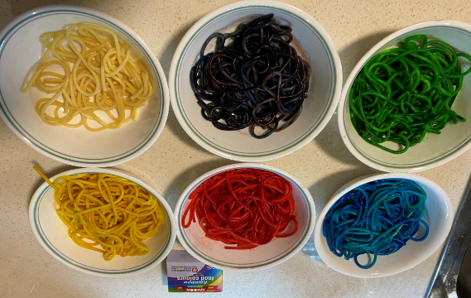
Ingredients:
Rainbow Spaghetti
- Coioked spagetti or noodles
- Food colouring
- Small amount of vegetable oil
Equipment:
- Bowls or containers
- Tongs, spoons
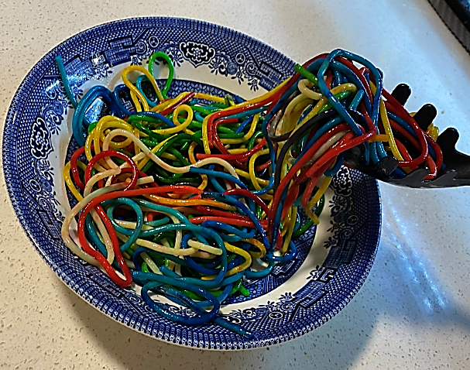
Method:
1. Cook the spagetti as packet instructions and then strain and rinse under cold water.
2. coat the spagetti in a small amount of oil
3. Divide spagetti into clean bowls (one for each colour)
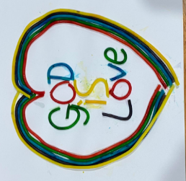
4. Add a fe drops of food colouring and with tongs mix the spagetti untill coloured. Add more drops of food colouring for a more intense colour.
Uses: Use the spagetti to make pictures, write messages, for colour play, you can even eat it to give colour to your meal!

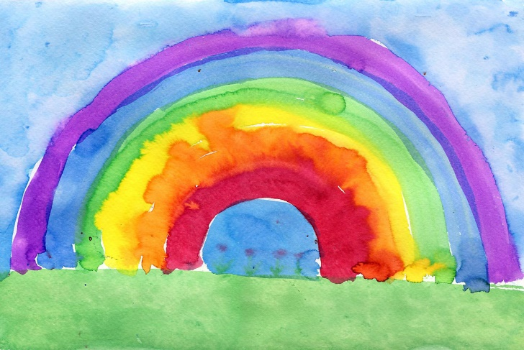
Make an encouragement Rainbow
Some promises to share
Here are some more of God’s promises from the Bible. Ask God who you need encouraging today and then send a promise verse to them.
Joshua 1:9 Be strong and brave. Don’t be afraid because the Lord your God will be with you wherever you go.
Jeremiah 29:11 ‘I say this because I know what I am planning for you,’ says the Lord. ‘I have good plans for your, not plans to hurt you. I will give you hope and a good future.
Mark 11:24 So I tell you to believe that you have received the things you ask for in prayer, and God will give them to you.
Romans 8:28 And we know that in all things work together for good for those who love God and are called according to his purpose.

In some towns and suburbs, people are putting rainbows in their windows to encourage people in their street.
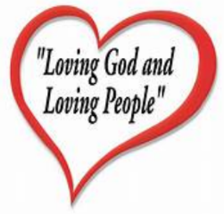
You will need: Paper,pens, paint and any other craft material you have around the house.
Use whatever craft materials you have to decorate a rainbow and put it in your window where your neighbours can see it.
Blessing
Say to each other at the end of your Messy Church at Home.
May God who loves you bless you and keep you safe. Amen

Your text here

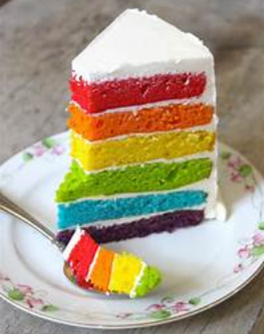
Messy Church Hospitality
Usually Messy Church finishes with a meal together. You might like to plan a colourful meal, or have afternoon tea with a special rainbow cake to remind you of God’s promises.
Grace: Thank you God for giving us food. Thank you God for giving us food. For the food we eat and the friends we can’t meet, thank you God for giving us food… da,da,di da… Amen (to Superman song)
Here are some other activities just for fun!

ANIMAL MASKS:
Cut out the middle section of a paper plate and draw an "animal plate" to wear as a mask. If you’ve got a big box you can make that into an ark to climb inside while you make the animal sounds

ARK TOSS: Gather your stuffed toy animals.
Have a large cardboard box decorated like an ark and cut holes in the "ark". You can take turns tossing small stuffed animals or toys into the holes and talk about the animals that went into the ark, as part of GOD's PLAN! What about taking a picture of your pet in the ark? God loves your pet too! Send your Messy Church team a picture of your pet in the ark.

This resource is compiled from various sources by Rev Beth Nicholls Project Officer Mission South Moreton Presbytery email: mission @southmoreton.org.au

PAPER PLATE - RAINBOW OVER THE ARK
Divide the paper plate in half with a line. On the bottom half draw and decorate to look like an ark. Cut out windows doors, deck. Draw or decorate or use sticker animals, Noah & family etc. Decorate the top half to look like a rainbow. You can write words like GOD'S PROMISES on the rainbow portion and write GOD'S PLAN on the ark portion. Put a small hole in the top and tread onto a string or cord to hang.

PIN ANIMAL ON THE ARK:
Cut out an ark shape out of a large piece of paper or cardboard. Use stickers or cut out pictures of animals from magazines. Then each person can take a turn, blindfolded, in trying to tape their little animal sticker, etc. on the ark. You could have someone being ‘Noah’ who gives instructions as to where the animals should go.

